Prestige Leisure Brand Images

Prestige are the distributors for the brands: Beechfield, Fruit of the Loom, Gildan, Henbury, Premier, and Russell.

The challenge is that the image url links are not included within the product CSV but are supplied separately.
In each of the rands, the image file name is the product SKU. For example within the Fruit of the Loom brand:
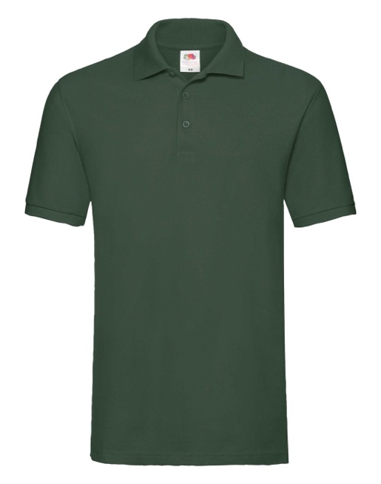<<< File name: “S3035M_BOG.jpg” aligns with product
SS035MBOG Bottle Green Polo shirt on CSV file. As you can see, the underscore would have to be removed on the image name for it to map exactly.

The only problem is that there are 6 size variants of the same SKU on the sheet which would technically have the same image, so there would have to be some way of attributing those 6 item variants to the one master image. For example all items below = the image above:

- SS035MBOGL
- SS035MBOGM
- SS035MBOGS
- SS035MBOGXL
- SS035MBOGXXL
- SS035MBOGXXXL

Prestige have also supplied a secondary file on 8th November with the image name included in the CSV, but I’m not sure if there is any way of linking these?

